System Review & Complete Overview

Quick Answer: Is Everything Ready to Publish?

Almost — but review these items first:

⚠️ Issues to Resolve Before Publishing

- Unsubscribe URL Mismatch — In email-outreach-microsoft365.json and followup-auto-send.json, the unsubscribe link points to https://www.styliquetechnologies.com/unsubscribe?email=... but the actual webhook handler in unsubscribe-handler.json listens at https://aiagent369.app.n8n.cloud/webhook/unsubscribe?email=.... These need to match.

- ~~Schedule Overlap~~ — RESOLVED. Follow-up auto-send trigger moved to 7:00 AM (was 8:00 AM). The digest still runs at 8:30 AM, giving a 1.5-hour buffer — enough to process 540+ emails at the 10s rate limit. No action needed.

- ~~email-outreach.json .first() bug~~ — RESOLVED. email-outreach-microsoft365.json now correctly uses $('Generate Tracking ID & Prep Data2').item.json to reference the current loop item. No action needed.

________________________________________________________________________________

Complete System Overview

What This System Does

The Stylique Lead Automation Agent is a fully automated n8n-based pipeline that finds fashion brands (via Instagram, Google Search, and LinkedIn), enriches their data, classifies them into service tiers, assigns them to sales team members, sends personalized AI-generated emails via Microsoft 365 Outlook, follows up automatically at Day 3, 7, and 14, tracks email opens, and sends daily team digests via Microsoft Teams and Email.

________________________________________________________________________________

System Architecture (End to End)

┌──────────────────────────────────────────────────────────────────────┐
│ DAILY EXECUTION TIMELINE │
│ │
│ 2:00 AM ─── Instagram Scraper (Apify) → New leads → Google Sheet │
│ 3:00 AM ─── Google Search Scraper (Serper) → New leads → Sheet │
│ 5:00 AM ─── Classification & Team Assignment → Sheet updated │
│ Daily ───── Apollo Enrichment → Email/phone → Sheet updated │
│ 7:00 AM ─── Auto Follow-Up Emails (Day 3/7/14) → Outlook → Sheet │
│ 8:30 AM ─── Daily Team Digest → Teams + Email │
│ 9:00 AM ─── Initial Outreach Emails (new leads) → Outlook → Sheet │
│ 9:00 AM ─── LinkedIn/Evaboot Import → New leads → Sheet │
│ On-demand ─ Email Open Tracking (webhook) → Sheet updated │
│ On-demand ─ Unsubscribe Handler (webhook) → Sheet updated │
└──────────────────────────────────────────────────────────────────────┘

________________________________________________________________________________

Module-by-Module Breakdown

MODULE 1: Lead Scraping (3 Sources)

Source | Workflow File | Trigger | What It Does
Instagram | instagram.json | Daily 2:00 AM | Uses Apify's Instagram Search Scraper to find fashion brands. Reads keywords/cities from InstagramSearchConfig sheet tab. Filters by minimum followers. Saves to CRM Sheet1.
Google Search | googlesearch.json | Daily 3:00 AM | Uses Serper API to find fashion brand websites. Reads queries from GoogleSearchSearchConfig sheet tab. Scrapes contact page, about page, and homepage for emails/phones. Detects e-commerce platform (Shopify, WooCommerce, etc).
LinkedIn | linkedin.json | Daily 9:00 AM | Reads Evaboot CSV exports from Google Drive. Reads file references from LinkedInSearchConfig sheet tab. Saves to both CRM Sheet1 and a separate Contacts sheet.

Weekly Rotation: All three scrapers use a weekly rotation system. The config sheet has multiple weeks of search parameters. The system automatically calculates which week to use based on floor((now - Jan 1 2025) / 7 days) % total_weeks.

MODULE 2: Data Enrichment

Workflow | Trigger | What It Does
apollo-enrichment.json | Daily (scheduled) | Two parallel paths: LinkedIn path — loops through LinkedIn contacts, checks for LinkedIn URL, calls Apollo's people/match API to find verified email. Other leads path — loops through Google Search/Maps/Instagram leads, calls Apollo's domain search API. Both paths extract decision-maker name, role, verified email, phone. Includes rate-limiting wait nodes between API calls and continueOnFail for resilience.

MODULE 3: Classification & Assignment

Workflow | Trigger | What It Does
classification-assignment.json | Daily 5:00 AM | Reads leads where AssignedSalesOwner is empty. Classifies into tiers based on website + followers. Reads team roster from TeamConfig sheet tab. Round-robin assigns to team members. Sets OutreachStatus based on enrichment state (e.g., "Ready for Outreach", "Pending Enrichment", "Manual Research Required"). Note: Follow-up dates are NOT set here — they are set by the email-outreach workflow after the email is successfully sent.

Classification Rules:
No website + <10K followers → Stylique Lite
Has website + <10K followers → Stylique Pro
Has website + ≥10K followers → Stylique Ultimate
No website + ≥10K followers → Stylique Pro (fallback)

Outreach Status Logic (set by classification):
- Ready for Outreach — enrichment complete + has email, OR already had email from scraper
- Manual Research Required — enrichment returned no email / no LinkedIn URL
- Pending Enrichment — not yet enriched

Team Assignment:
- Reads Team_Config tab dynamically (no hardcoded names)
- Filters for Active=TRUE and Receives_Leads=TRUE
- Matches lead's tier to team member's Tier_Assignment column
- Round-robin within matching members

MODULE 4: Initial Email Outreach

Workflow | Trigger | What It Does
email-outreach-microsoft365.json | Daily 9:00 AM | Reads leads where Outreach_Status = "Ready for Outreach". Generates personalized email using Groq Llama 3.3 70B. Builds branded HTML email with banner, CTA button, unsubscribe link, and tracking pixel. Sends via Microsoft 365 Outlook. Updates CRM status to "Email Sent".

AI Email Generation:
- System prompt positions Stylique as a "confidence layer" (not a design tool)
- Includes brand-specific data: name, website, Instagram, city, platform
- Returns JSON with subject, headline, body
- Fallback template exists if AI fails

MODULE 5A: Auto Follow-Up Emails

Workflow | Trigger | What It Does
followup-auto-send.json | Daily 7:00 AM | Reads all leads. Filters where FollowUpDate ≤ today AND status is "Email Sent", "Follow-Up 1 Sent", or "Follow-Up 2 Sent". Determines round (1, 2, or 3). Generates AI follow-up with round-specific tone. Sends via Outlook. Updates next follow-up date.

Cadence:
Day 0: Initial email sent (Follow_Up_Date set to +3 days)
Day 3: Follow-Up 1 (gentle nudge, next in +4 days)
Day 7: Follow-Up 2 (more direct/urgent, next in +7 days)
Day 14: Follow-Up 3 (breakup email, "Should I close your file?", closure in +3 days)
Day 17: Round 4 — CLOSURE (NO email sent, status update only)
→ If email was opened: mark "Warm - Email Opened"
→ If never opened: mark "Cold - No Response"

MODULE 5B: Team Digests & Reminders

Workflow | Trigger | What It Does
followup-reminders.json | Daily 8:30 AM | Reads TeamConfig and all leads. Deduplicates leads by LeadKey. Builds personalized digest per team member (assigned leads only) or full-team summary for report-only members. Sends Microsoft Teams Adaptive Card v1.4 + branded HTML email via Outlook to each member.

Digest Sections (10 total):
- 🆕 New Leads Today — leads scraped today, broken down by source
- 🔬 Enrichment Pipeline — status counts (Completed, Has Email, Pending Apollo, Manual Research, Failed, Pending) with email coverage percentage
- 🔥 Hot Leads — emails that were opened, sorted by open count, with location/tier/status
- 📬 Follow-Ups — Due Today + Overdue, showing follow-up round (Day 3/7/14)
- 📊 Engagement Activity — opens today, total unique opens, responses, meetings booked, plus full funnel visualization
- ✅ Auto Follow-Ups Sent Today — follow-ups processed this morning
- 📈 Source & Tier Distribution — lead counts by discovery source and service tier
- 👥 Team Performance — (report-only viewers) per-member stats: assigned, emails sent, opens, responses, response rate
- 🩺 Email Delivery Health — failed emails, unsubscribes, leads missing email addresses
- ❄️ Recently Marked Cold — leads marked cold in last 3 days

Summary Bar: 6 key metrics displayed at top — Hot, New Today, Due Today, Overdue, Sent Today, Pipeline

________________________________________________________________________________

Supporting Webhooks

Workflow | Endpoint | What It Does
email-tracking-webhook.json | GET /webhook/track/open?id=UUID | Embedded as 1x1 pixel in every email (initial + all follow-ups). On load: looks up lead in CRM by tracking ID, increments EmailOpenCount, sets EmailOpened=TRUE, records EmailFirstOpenedAt (only on first open). Returns transparent 1x1 GIF.
unsubscribe-handler.json | GET /webhook/unsubscribe?email=X | Sets OutreachStatus = "Unsubscribed", clears FollowUp_Date. Returns styled confirmation page.

________________________________________________________________________________

Google Sheets Architecture

Spreadsheet: Stylique_Lead_CRM (ID: 1nBCc2_p6s1mQznskmHf5HUH9pJ8P8qXDhzI5gDRVlTs)

Tab | Purpose | Managed By
Sheet1 (gid=0) | Main CRM — all leads, 40+ columns | System (automated)
Team_Config (gid=250695418) | Team roster — names, emails, tiers, active status | Client (manual edits)
InstagramSearchConfig | Instagram scraping keywords, cities, min followers per week | Client (manual edits)
GoogleSearchSearchConfig | Google Search queries, results per query per week | Client (manual edits)
LinkedInSearchConfig | LinkedIn/Evaboot file names, folder IDs per week | Client (manual edits)

Secondary Spreadsheet: Contacts (ID: 1zM2XI6kJFrjJoCoaB6Md6HoLRMF7_UwMmgkeviDKV0M)
- Stores LinkedIn individual contacts (separate from company-level CRM)
- Used by Apollo enrichment to match LinkedIn URLs to emails

________________________________________________________________________________

What the Client Needs to Do

One-Time Setup (Already Done)
- ✓ n8n cloud instance configured
- ✓ Google Sheets OAuth connected
- ✓ Microsoft 365 Outlook OAuth connected (hello@styliquetechnologies.com)
- ✓ Groq API key configured
- ✓ Apify account connected (Instagram scraping)
- ✓ Serper API key (for header auth)
- ✓ Apollo.io API key (for header auth)
- ✓ Microsoft Teams incoming webhook created
- ✓ Google Drive OAuth connected (for Evaboot CSV access)
- ✓ Cloudinary banner image uploaded

Ongoing Client Responsibilities

- Manage Team Roster — Edit the Team_Config tab:
- Add/remove team members (no code changes needed)
- Toggle Active to pause a member
- Change Tier_Assignment to reassign tier responsibilities
- Set Receives_Report=TRUE for exec-level visibility without lead assignments

- Manage Search Configurations — Edit the config tabs weekly/monthly:
- InstagramSearchConfig: Add new keywords, cities, adjust min followers
- GoogleSearchSearchConfig: Add new search queries, adjust results count
- LinkedInSearchConfig: Update Evaboot file references after new exports

- Upload Evaboot Exports — Place new LinkedIn CSV exports in the configured Google Drive folder

- Monitor CRM — Review Sheet1 for:
- Hot leads (Email_Opened = TRUE) → Manually engage
- Responded leads → Update Outreach_Status to "Responded"
- Meeting booked → Update status, add call notes
- Manual research needed → Fill in missing emails for leads marked "Manual Research Required"

- Check Teams/Email Digests — At 8:30 AM daily, team members receive:
- Which leads opened emails (priority action)
- Which follow-ups went out automatically
- Which leads went cold

________________________________________________________________________________

Lead Lifecycle (Status Flow)

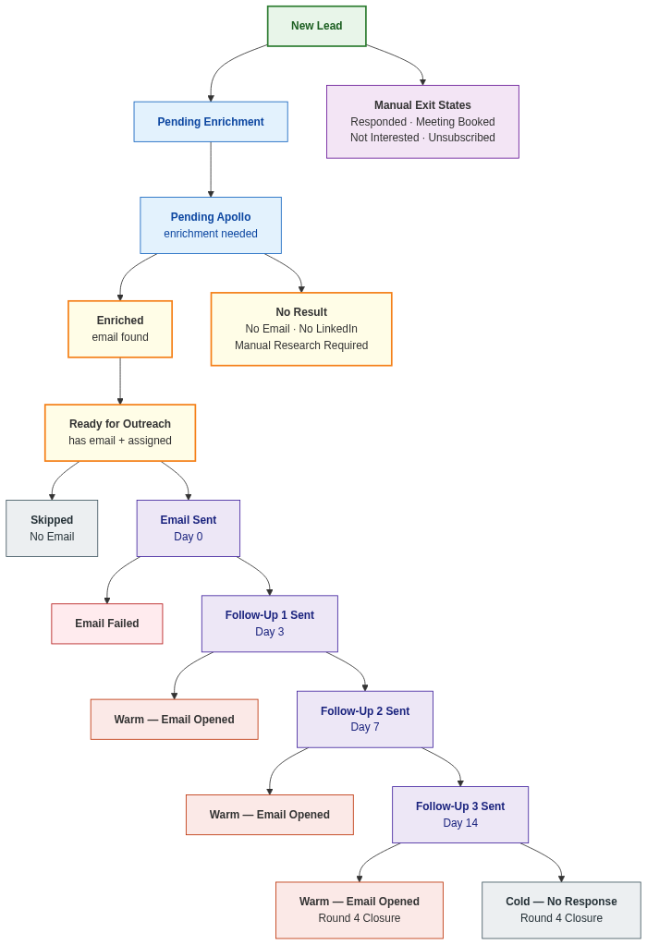
Figure: Lead Lifecycle Status Flow

________________________________________________________________________________

Final Publish Checklist

- ✓ Fix .first().json → .item.json in email template nodes — DONE (email-outreach-microsoft365.json now uses .item.json)
- ☐ Fix unsubscribe URL in email templates to point to https://aiagent369.app.n8n.cloud/webhook/unsubscribe (or configure a redirect from styliquetechnologies.com)
- ☐ Test each workflow individually with 1-2 test leads before enabling schedules
- ☐ Verify all OAuth credentials are active (Google Sheets, Outlook, Google Drive, Apify)
- ☐ Confirm Teams webhook URL is still active
- ☐ Enable all scheduled triggers in n8n

Once those items are resolved, the system is ready for production.

